- \Operation\Basic settings\settings
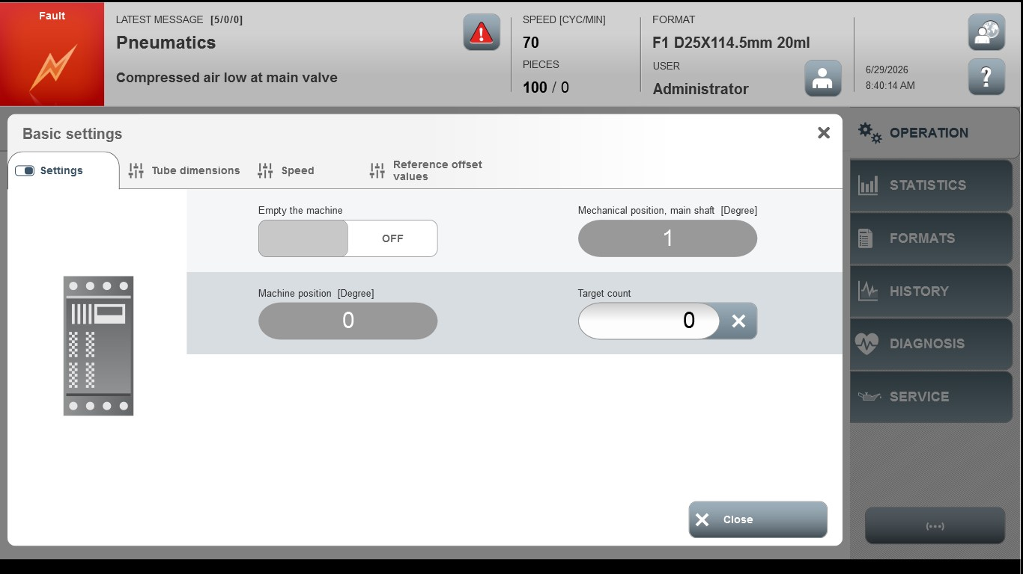
Acceptance criterion | Limits | Pass / Fail: Dev-No. | Date | Initials
Screen matches screenshot | N / A
Target count | 0 … 2000000000

